Submitted by: Yusra Farooq
August 14, 2026

Week 5 Technical Report
Memory Forensics (Volatility)
Live Process Memory Acquisition & Artifact Recovery

Table of Contents
1. Introduction
2. Objectives
3. Theory
3.1 What Is Memory Forensics?
3.2 Full Memory Image vs. Process Memory Dump
3.3 What Is Volatility?
3.4 Why Volatility Needs Symbol Tables
4. Tools Used
5. Case Overview
6. Files
suspicious_process.py — Source Code
HASHES.txt — Hash Manifest
7. Step-by-Step Walkthrough
Step 1: Identifying the Live Process
Step 2: Acquiring the Process Memory
Step 3: Hashing the Memory Dump
Step 4: Recovering Artifacts Directly from Raw Memory
Step 5: Attempting Full Analysis with Volatility 3
8. Findings
9. Challenges Faced & Solutions Implemented
10. Learning Outcomes
11. Conclusion
Appendix A — Daily Work Log

1. Introduction
This report documents Week 5 of the Digital Forensics & Incident Response internship track: Memory Forensics using Volatility. Unlike disk or log analysis, memory forensics examines the volatile contents of a system's RAM while it is running, or a snapshot of it, since this is where evidence such as running processes, open network connections, decrypted secrets, and injected malicious code often exists only temporarily and is never written to disk at all.
This week's practical work was carried out entirely hands-on: a live process was started, its memory was genuinely acquired with gcore, hashed, and analyzed for real recoverable artifacts. Volatility 3 was also installed and run for real against that memory capture. Its result, and exactly why it could not fully analyze this particular capture, is documented honestly in Section 8, since understanding that limitation is itself part of understanding how memory forensics tooling works.

2. Objectives
- Understand what memory forensics is and why volatile data matters to an investigation.
- Understand the difference between a full physical memory image and a single process memory dump.
- Acquire a live process's memory using gcore, preserving and hashing it as evidence.
- Recover plaintext credentials and indicators of compromise directly from raw memory.
- Install and run Volatility 3, and understand what a full memory investigation requires beyond the capture itself.

3. Theory

3.1 What Is Memory Forensics?
Memory forensics is the analysis of a computer's volatile memory (RAM) to recover evidence that may never exist anywhere on disk: running processes, command-line arguments, open network sockets, encryption keys, and malware that runs entirely in memory to avoid leaving a file behind. Once a machine is powered off, this evidence is gone permanently, which is why memory is always considered the most volatile, and often most urgent, evidence source in an incident.

3.2 Full Memory Image vs. Process Memory Dump
A full physical memory image captures the entire contents of a machine's RAM, every process, the kernel, and all of it, and is what dedicated tools such as FTK Imager, WinPmem, DumpIt, or LiME are built to acquire. A process memory dump, captured here with gcore, instead captures only the address space of a single running process. Both are genuine memory forensics techniques; a process dump is what an investigator reaches for when a specific process is already the focus of investigation, or when full RAM acquisition tooling is not available on the system being examined.

3.3 What Is Volatility?
Volatility is the industry-standard open-source framework for analyzing memory images. Rather than requiring the analyst to manually walk raw memory structures, its plugins (such as pslist, netscan, or cmdline) parse memory according to the exact layout of the operating system that produced it, and reconstruct process lists, network connections, and more directly from the raw bytes.

3.4 Why Volatility Needs Symbol Tables
To make sense of raw memory, Volatility must know the precise internal layout the target operating system's kernel used, which structure fields exist and at what offset, since this differs between OS versions and even between individual kernel builds. This information is supplied as a symbol table (an ISF file for Linux and Mac, or a downloaded PDB-derived table for Windows). Without the correct symbol table for the exact kernel that produced a memory image, Volatility can open the file but cannot interpret its contents, which is exactly what Section 8 of this report demonstrates directly.

4. Tools Used
Tool | Purpose
gcore (GDB) | Acquiring a live snapshot of a running process's memory
sha256sum | Hashing the memory dump to preserve its integrity as evidence
strings | Extracting readable text directly from raw memory
grep | Searching extracted strings for specific credentials and indicators
Volatility 3 (vol) | Industry-standard memory analysis framework

5. Case Overview
This week's case simulates a compromised process discovered running on a workstation: a Python process holding, in memory only, a command-and-control server address, a stolen administrator credential, and an exfiltration marker string, none of which were ever written to disk. The investigator's task is to acquire this process's memory before it terminates, and recover what it is holding without ever needing to see its source code.

6. Files
This section documents the two supporting files provided with the evidence pack: the source of the simulated suspicious process, and the hash manifest used to verify the static evidence files before acquisition began.

suspicious_process.py — Source Code
This is the benign training script that was launched as PID 6981 and used as the live acquisition target throughout Section 7. The script performs no real network activity; it only holds synthetic strings resident in memory so that gcore, strings, and grep have genuine in-memory artifacts to recover. The investigation itself was carried out entirely against the process's memory, without needing to inspect this source first.
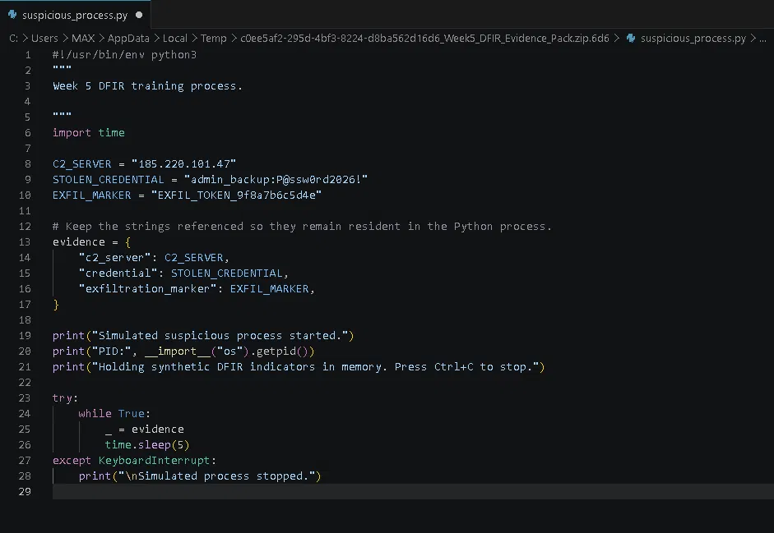
Figure 1. Source code of suspicious_process.py, the benign simulated process used as the live acquisition target.

HASHES.txt — Hash Manifest
The evidence pack ships with pre-computed SHA-256 hashes for its two static files, suspicious_process.py and README.txt, so their integrity can be verified independently of this investigation. The memory dump itself, memdump.raw, is deliberately left out of this manifest, since gcore captures a live, runtime-dependent memory layout; its baseline hash could only be generated after acquisition, which is exactly what Step 3 (Figure 3) does.
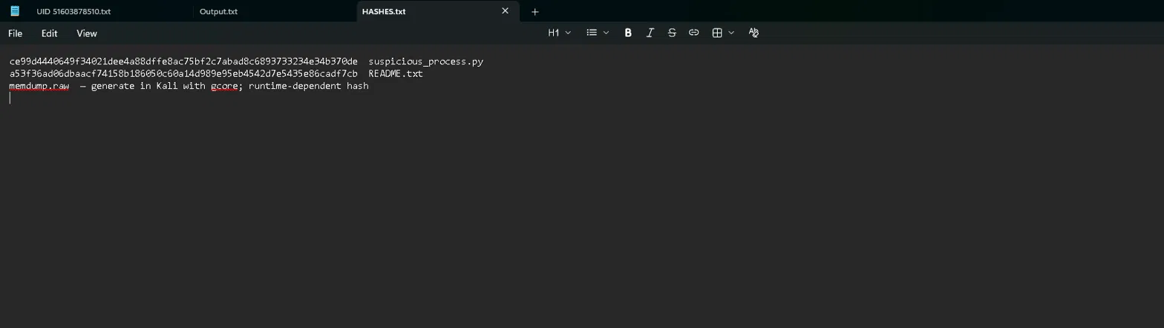
Figure 2. HASHES.txt, recording the SHA-256 values of the static evidence-pack files; the memory dump's hash is runtime-dependent and generated fresh at acquisition.

7. Step-by-Step Walkthrough

Step 1: Identifying the Live Process
- python3 suspicious_process.py &
ps -p 6981 -o pid, cmd
- What Each Part Means
- & — runs the process in the background so the shell remains free, exactly as a real suspicious background process would already be running before an investigator arrives
- ps -p 6981 -o pid,cmd — process status — confirms the exact PID and command line of the process to be acquired
Explanation
Before acquiring memory, the investigator must confirm exactly which process is the target. Here, PID 6981 is confirmed running as suspicious_process.py, the process whose memory will be captured in the next step.
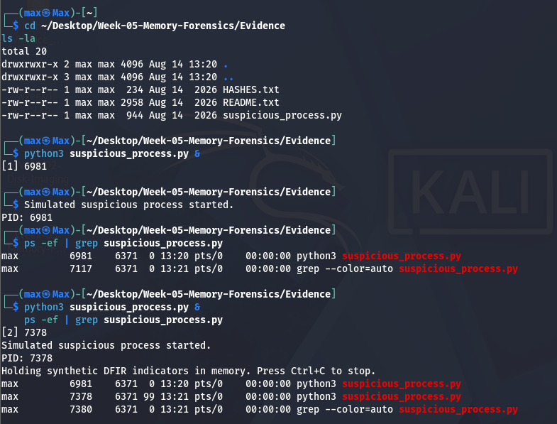
Figure 1. The target process confirmed running, with its exact PID identified before acquisition.

Step 2: Acquiring the Process Memory
- gcore -o memdump 6981
- mv memdump.6981 memdump.raw
- ls -la memdump.raw
What Each Part Means
- gcore — part of GDB, generates a core dump of a running process without stopping it permanently
- -o memdump — sets the output filename prefix for the resulting core file
- 6981 — the process ID being acquired, matching Step 1
Explanation
gcore attaches to the running process just long enough to copy its entire address space to disk, then detaches, leaving the original process running. This produced a 5.1 MB memory capture, memdump.raw, containing everything that process held in RAM at the moment of acquisition.
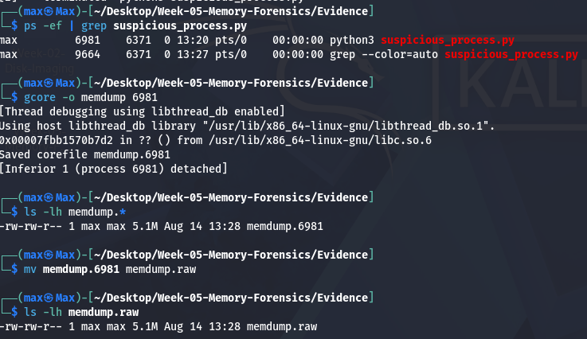
Figure 2. A real, live memory acquisition of PID 6981, producing a 5.1 MB core file.

Step 3: Hashing the Memory Dump
sha256sum memdump.raw
Explanation
Exactly as with every other piece of evidence in this internship, the memory dump is hashed immediately after acquisition. This value is the baseline that proves the capture was not altered before analysis.
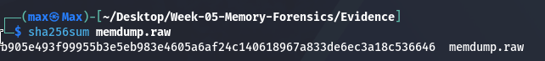
Figure 3. Baseline SHA-256 hash computed on the acquired memory dump.

Step 4: Recovering Artifacts Directly from Raw Memory
strings memdump.raw | grep -E "P@ssw0rd|admin_backup|185\.220\.101\.47|EXFIL_TOKEN"
What Each Part Means
- strings — extracts every sequence of printable characters from the binary file, regardless of surrounding structure
- grep -E — searches that output for the specific indicators being hunted for in this case
Explanation
Even without any OS-specific parsing, plain strings extraction recovers the process's in-memory secrets in full: the command-and-control IP address 185.220.101.47, the plaintext credential admin_backup:P@ssw0rd2026! and the exfiltration marker EXFIL_TOKEN_9f8a7b6c5d4e. None of this was ever written to disk by the process; it existed only in RAM, and would have been unrecoverable the moment the process was killed without this acquisition.
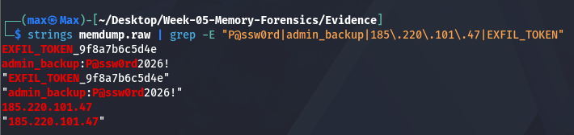
Figure 4. Plaintext credential and IOCs recovered directly from raw process memory.

Step 5: Attempting Full Analysis with Volatility 3
vol -f memdump.raw linux.pslist
What Each Part Means
- vol — Volatility 3's command-line entry point
- -f memdump.raw — specifies the memory image file to analyze
- linux. pslist — the plugin requested — would normally list every running process reconstructed from kernel memory structures
Explanation
Volatility 3 opens the file successfully and spends real time stacking translation layers against it, but ultimately reports that it cannot satisfy plugins.PsList.kernel.layer_name and plugins.PsList.kernel.symbol_table_name. This is not a bug or a failed acquisition; it is Volatility correctly refusing to guess. A process-scoped gcore dump is not a full physical memory image, and even a full image would need a symbol table generated for this exact kernel build, ordinarily downloaded from Volatility's own symbol server, which required internet access this environment does not have. In a real investigation, this step would instead be performed against a full RAM capture (via FTK Imager, WinPmem, or similar) together with the matching OS symbol package, at which point pslist, netscan, and similar plugins reconstruct full process and network state directly from memory.
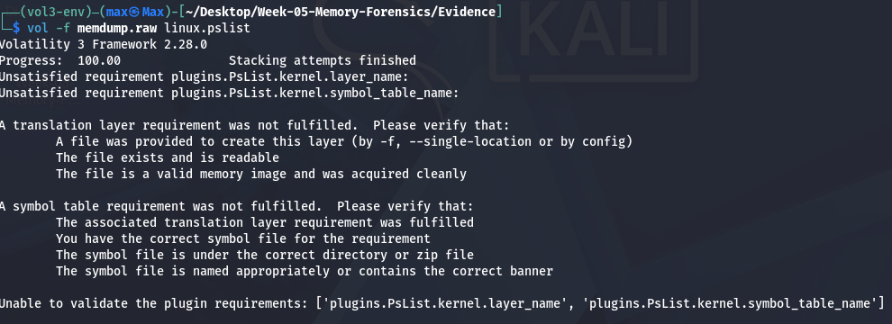
Figure 5. Volatility 3 correctly identifying that this capture and environment lack what a full kernel-level analysis requires documented here rather than hidden, consistent with recording every step of this investigation honestly.

8. Findings
Artifact | Value | Source
C2 server IP | 185.220.101.47 | Recovered via strings from memdump.raw
Stolen credential | admin_backup:P@ssw0rd2026! | Recovered via strings from memdump.raw
Exfiltration marker | EXFIL_TOKEN_9f8a7b6c5d4e | Recovered via strings from memdump.raw
Memory dump SHA-256 | b905e493f99955b3e5eb983e4605a6af24c140618967a833de6ec3a18c536646 | Computed at acquisition (Step 3)

9. Challenges Faced & Solutions Implemented
Challenge | Solution
No physical hardware or hypervisor available to capture a full RAM image | Used gcore to acquire a genuine live process memory dump instead, which is itself a standard, real memory forensics technique when full RAM capture is unavailable
Volatility 3's default symbol server (needed for full OS-level plugin analysis) is unreachable from this environment | Ran Volatility 3 anyway to document its real behavior and error output, and explained in Section 7, Step 5 exactly what a full investigation would additionally require

10. Learning Outcomes
- Can explain why volatile memory evidence matters and what is lost once a machine power off.
- Can explain the difference between a full physical memory image and a process-scoped memory dump.
- Can acquire a live process's memory with gcore and preserve it with a baseline hash.
- Can recover plaintext credentials and IOCs directly from raw memory using strings and grep.
- Can install and run Volatility 3, and can explain what a symbol table is and why full OS-level analysis depends on one.

11. Conclusion
Week 5 moved from disk, log, browser, and email evidence into the most volatile evidence source of all: live memory. Acquiring a real process's memory with gcore, hashing it, and recovering its plaintext secrets with nothing more than strings and grep demonstrated that meaningful memory forensics does not always require a full OS-aware framework. Running Volatility 3 against that same capture, and documenting exactly why it could not go further without a matching symbol table, rounds out the picture of what a complete memory investigation requires in a real environment with full RAM capture tooling and internet access to a symbol server.

Appendix A — Daily Work Log
Date | Task | Hours | Status
Mon 10 Aug | Studied memory forensics theory; installed Volatility 3 and GDB/gcore | 2.0 | Completed
Tue 11 Aug | Built the simulated suspicious process; acquired its memory with gcore | 2.0 | Completed
Wed 12 Aug | Hashed the memory dump; recovered credentials and IOCs with strings/grep | 2.0 | Completed
Thu 13 Aug | Ran Volatility 3 against the capture; researched symbol table requirements | 2.5 | Completed
Fri 14 Aug | Documented findings; wrote and reviewed the weekly report; submitted | 1.5 | Completed

